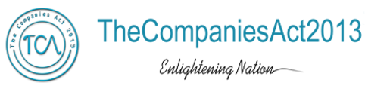
Annexure- V
Format for the Limited Review Report for companies (other than banks)

Review Report to …………………….

We have reviewed the accompanying statement of unaudited financial results of …………………………….. (Name of the Company) for the period ended…………. This statement is the responsibility of the Company’s Management and has been approved by the Board of Directors. Our responsibility is to issue a report on these financial statements based on our review.

We conducted our review in accordance with the Standard on Review Engagement (SRE) 2400, Engagements to Review Financial Statements issued by the Institute of Chartered Accountants of India. This standard requires that we plan and perform the review to obtain moderate assurance as to whether the financial statements are free of material misstatement. A review is limited primarily to inquiries of company personnel and alytical procedures applied to financial data and thus provide less assurance than an audit. We have not performed an audit and accordingly, we do not express an audit opinion.

Based on our review conducted as above, nothing has come to our attention that causes us to believe that the accompanying statement of unaudited financial results prepared in accordance with applicable accounting standards and other recognized accounting practices and policies has not disclosed the information required to be disclosed in terms of Regulation 33 of the SEBI (Listing Obligations and Disclosure Requirements) Regulations, 2015 including the manner in which it is to be disclosed, or that it contains any material misstatement.

For XYZ & Co. Chartered Accountants

Place of signature
Date

1 Partner or proprietor, as the case may be.
Signature
Name of the member signing the audit report)
(Designation) 1
(Membership Number)

